Set 7: Customer Demographics Analysis
Dataset: Customer Demographics
Customer ID | Age | Gender | Income (in $)
1 | 28 | Female | 50000
2 | 35 | Male | 60000
3 | 42 | Female | 75000

Question 1: Bar Chart of Customer Ages
Create a bar chart to visualize the distribution of customer ages. Label the axes and title the chart.
Answer:
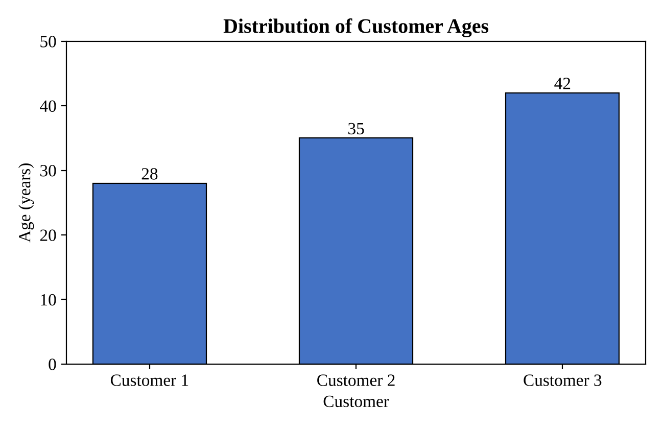
The three customers are 28, 35 and 42 years old, so their ages are spread fairly evenly over a range of 14 years, with a mean age of 35. Customer 1 is the youngest and Customer 3 is the oldest. Each customer belongs to a different age band (the 20s, the 30s and the 40s).
Question 2: Pie Chart of Customers by Gender
Generate a pie chart to represent the distribution of customers by gender.
Answer:
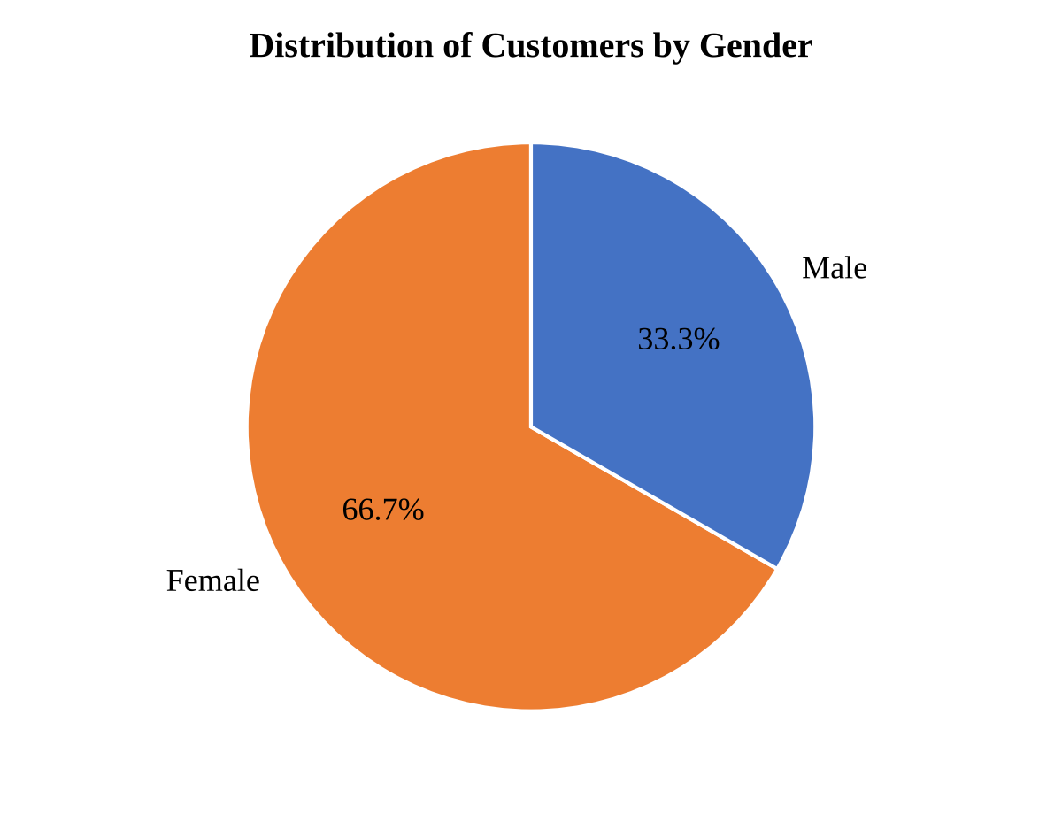
Two of the three customers are female (66.7%) and one is male (33.3%). Because the dataset contains only three customers, these percentages are only a rough indication of the gender split.
Question 3: Table of Demographic Information
Build a table to show the demographic information for each customer. Label the table elements.
Answer:
Table 1: Demographic Information of Customers
Customer ID | Age (years) | Gender | Income (in $)
1 | 28 | Female | 50,000
2 | 35 | Male | 60,000
3 | 42 | Female | 75,000

Each row represents one customer and each column shows one characteristic: age, gender or income. In this data, income increases with age, from $50,000 at age 28 to $60,000 at age 35 and $75,000 at age 42. The average age is 35 years and the average income is about $61,667.
Question 4: Tableau Dashboard
Develop a Tableau dashboard combining the bar chart, pie chart, and the table for interactive exploration of customer demographics.
Answer:
Tableau is a desktop application, so the dashboard file itself cannot be created inside this document. The preview below shows the intended layout, and the steps explain how to build it.
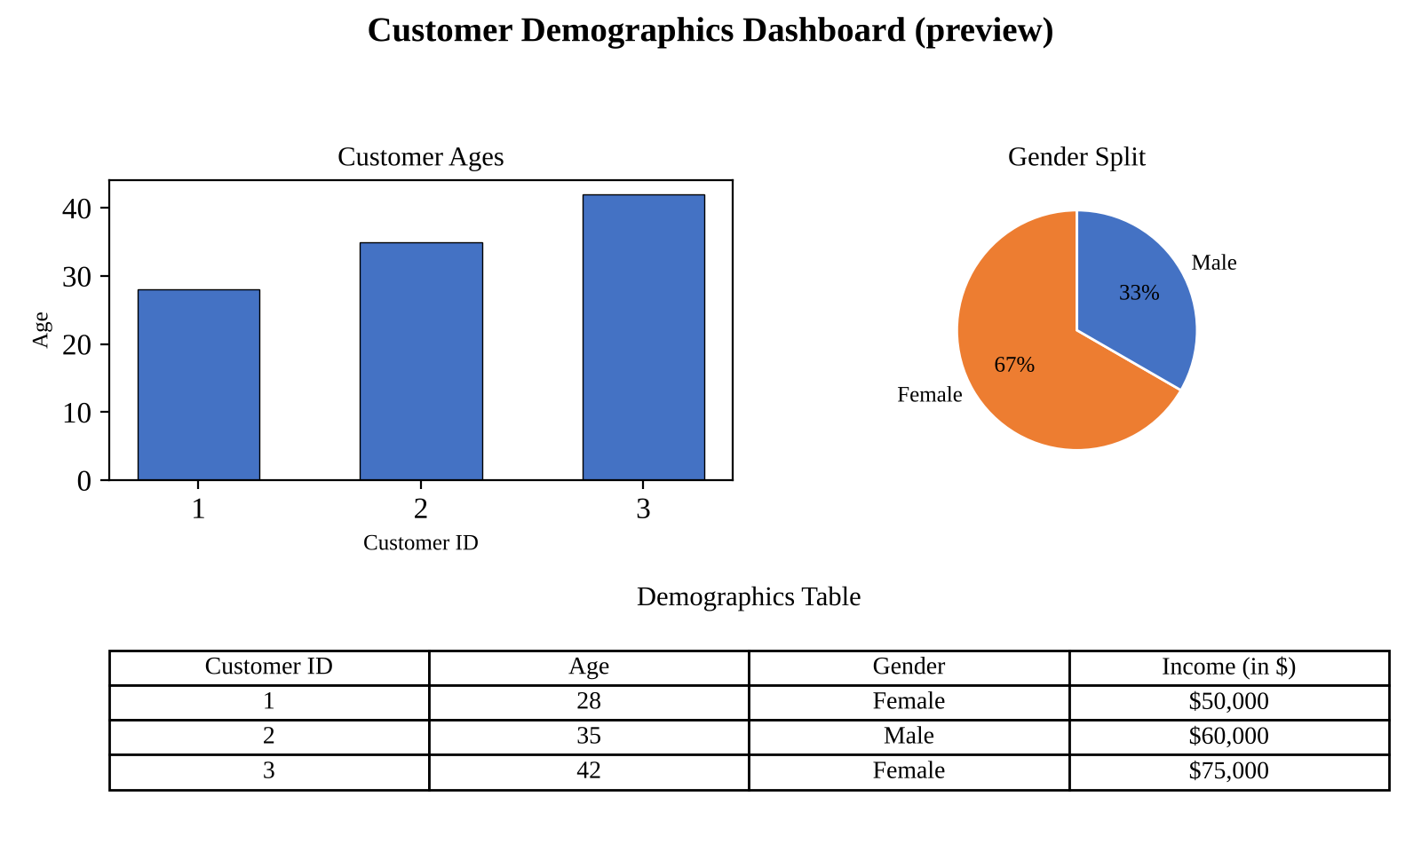
- Open Tableau and connect to customer_demographics.csv. Right-click Customer ID and convert it to a Dimension.
- Sheet 1 (bar chart): drag Customer ID to Columns and Age to Rows, and show the value labels.
- Sheet 2 (pie chart): choose Pie on the Marks card, put Gender on Color and Number of Records on Angle, and show the percentage of total as a label.
- Sheet 3 (table): drag Customer ID and Gender to Rows, then use Measure Names on Columns and Measure Values on Text, keeping only Age and Income.
- Create a new dashboard, drag the three sheets onto it, turn on “Use as Filter” for each, and add a Gender filter.
- Add a dashboard title, then save the workbook (.twbx) or publish it to Tableau Public.

